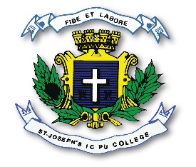
ST. JOSEPH’S INDIAN COMPOSITE PU COLLEGE
#23, Vittal Mallya Road, Bangalore – 560001.

SUBJECT: ENGLISH (02)
II PUC
SYLLABUS FOR I TEST – 2023-24

Text Book - Units : 1. Romeo and Juliet
2. Too Dear
3. On Children
4. Everything I need to know I learned in the Forest.
Grammar - Comprehension Passage, Poetry Comprehension
(1-3 poems), Passive Voice, Dialogue Writing,
Expressions, Jumbled segments, Pronouns.

